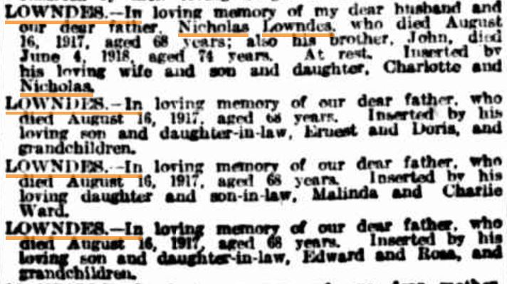
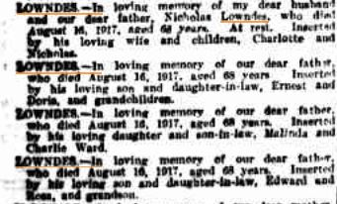
2870 1918-08-16 SMH p6 In Memoriam.JPG 2870 1919-08-16 SMH p16 In Memoriam.JPG

2870 1921-08-16 SMH p8 In Memoriam.JPG
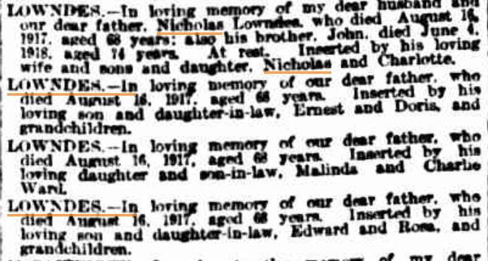
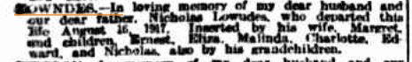

2870 1920-08-16 SMH p8 In Memoriam.JPG

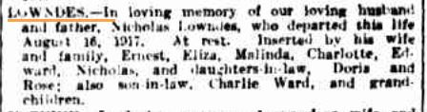
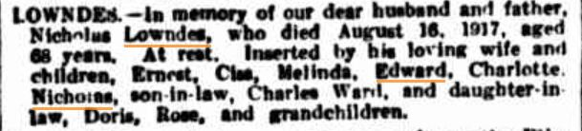

2870 1922-08-16 SMH p10 In Memoriam.JPG 2870 1923-08-16 SMH p8 In Memoriam.JPG

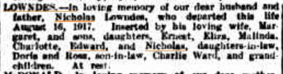
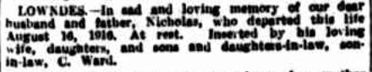
2870 1924-08-16 SMH p14 In Memoriam.JPG 2870 1925-08-15 SMH p14 In Memoriam.JPG

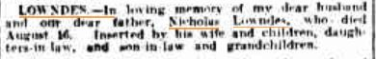
2870 1925-08-15 SMH p14 In Memoriam.JPG 2870 1926-08-16 SMH p10 In Memoriam.JPG

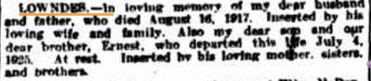
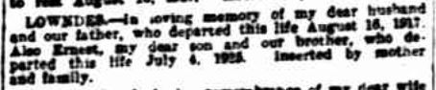
2870 1927-08-16 SMH p10 In Memoriam.JPG 2870 1928-08-16 SMH p10 In Memoriam.JPG

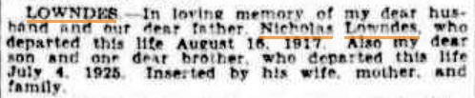
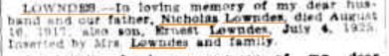
2870 1929-08-16 SMH p10 In Memoriam.jpg 2870 1930-08-16 SMH p13 In Memoriam.JPG

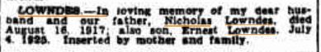

2870 1931-08-15 SMH p12 In Memoriam.JPG

