
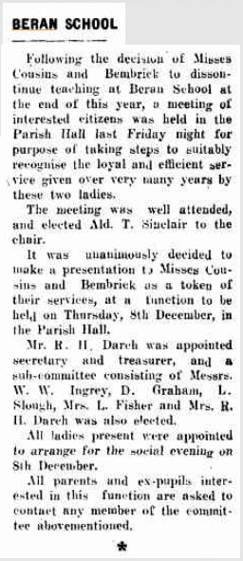

2787 1949-11-07 GRecord p2 Closure.png

2787 1949-11-14 GRecord p2 Closure.png

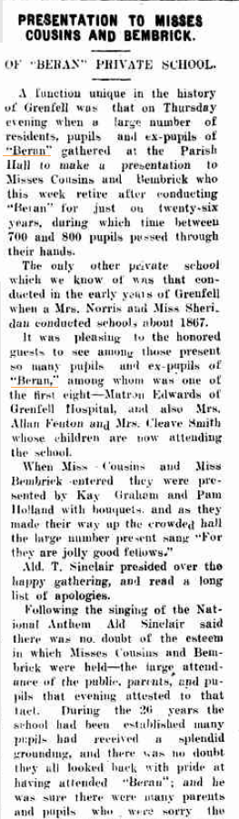


2787 1949-12-12 GRecord p2A Closure.png

2787 1949-12-12 GRecord p2B Closure.png




2787 1949-12-12 GRecord p2C Closure.png


2787 1949-12-12 GRecord p2E Closure.png

2787 1949-12-12 GRecord p2D Closure.png

